VitaTrack – Daily Lifestyle Health Risk Predictor
A Project Based Learning Report Submitted in partial fulfilment of the requirements for the award of the degree

of

Bachelor of Technology
in The Department of CSE
24SDCS02A-FULL STACK APPLICATION DEVELOPMENT

Submitted by
2410030341: UMAR MOHAMMAD
24100303169: LOKESH JAMI
2410030300: BALASAI
2410030449: JAYENDRA VARMA

Under the guidance of
Dr.G.Madhukar Rao


Department of Computer Science and Engineering

Koneru Lakshmaiah Education Foundation, Aziz Nagar
Aziz Nagar – 500075
FEB - 2026.
Introduction

In recent years, lifestyle-related diseases such as diabetes, hypertension, obesity, and cardiovascular disorders have increased significantly due to unhealthy daily habits. Factors such as poor diet, irregular sleep cycles, lack of physical activity, prolonged screen time, and high stress levels contribute heavily to long-term health risks. However, most individuals fail to recognize early warning signs until medical conditions become severe. This highlights the growing need for preventive healthcare systems that can monitor lifestyle patterns and provide early risk predictions.
To address this challenge, the project “VitaTrack – Daily Lifestyle Health Risk Predictor” is developed as a full-stack web application designed to analyze users’ day-to-day lifestyle behaviors and estimate potential health risks. The system collects inputs such as food habits, water intake, exercise frequency, sleep duration, stress levels, and digital device usage. Using predefined health rules and predictive logic, the application evaluates the data and generates personalized risk assessments along with preventive health suggestions.
The platform aims to promote health awareness and encourage users to adopt balanced lifestyle practices. Built using modern full-stack technologies, VitaTrack integrates an interactive user interface, secure data handling, and analytical modules for risk calculation. The system not only predicts risks but also educates users through insights, tips, and progress tracking dashboards. Ultimately, VitaTrack contributes to the broader vision of preventive healthcare by empowering individuals to make informed lifestyle decisions before medical intervention becomes necessary.

- METHODOLOGY / IMPLEMENTATION
(Minimum 1200 words)
- Overview of the Proposed System
The VitaTrack – Daily Lifestyle Health Risk Predictor is designed to monitor and analyze the daily lifestyle habits of users and provide insights into their overall health condition. The system focuses on preventive healthcare by identifying potential health risks that arise due to unhealthy lifestyle patterns such as lack of sleep, poor diet, insufficient exercise, high stress levels, and excessive screen time.
The methodology of the proposed system emphasizes collecting lifestyle data from users through a web-based interface, analyzing the data using predefined health evaluation rules, and generating a health score that indicates the user's overall lifestyle quality. The system also provides recommendations and health improvement suggestions to encourage healthier habits.
The application aims to address the growing problem of lifestyle-related diseases by helping users become aware of how their daily routines impact their health. By continuously monitoring health indicators, users can make better decisions regarding sleep patterns, exercise routines, diet habits, and stress management.
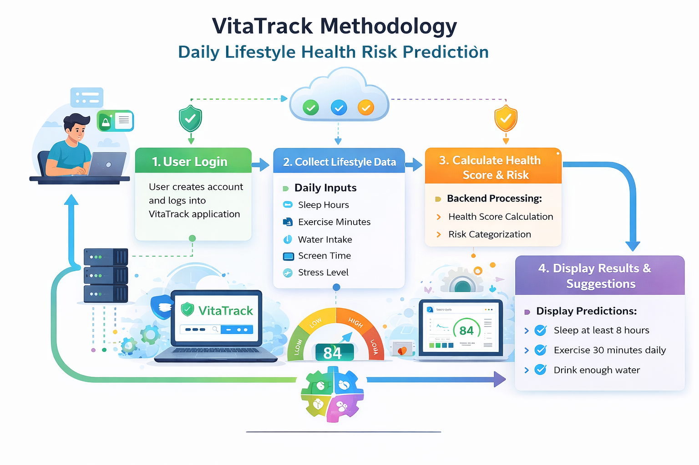

- System Methodology
The methodology of the VitaTrack system follows a structured approach consisting of data collection, lifestyle analysis, health risk prediction, and visualization of results.
The first stage of the system involves user authentication and login. Users create an account through the signup page and log into the application securely. After successful login, users gain access to the personalized health dashboard where they can enter their daily lifestyle data.
The second stage involves data collection from the user. The system gathers information related to important lifestyle parameters such as sleep hours, exercise duration, water intake, junk food consumption, heart rate, and stress levels. These parameters are selected because they play a critical role in determining a person’s physical and mental well-being.
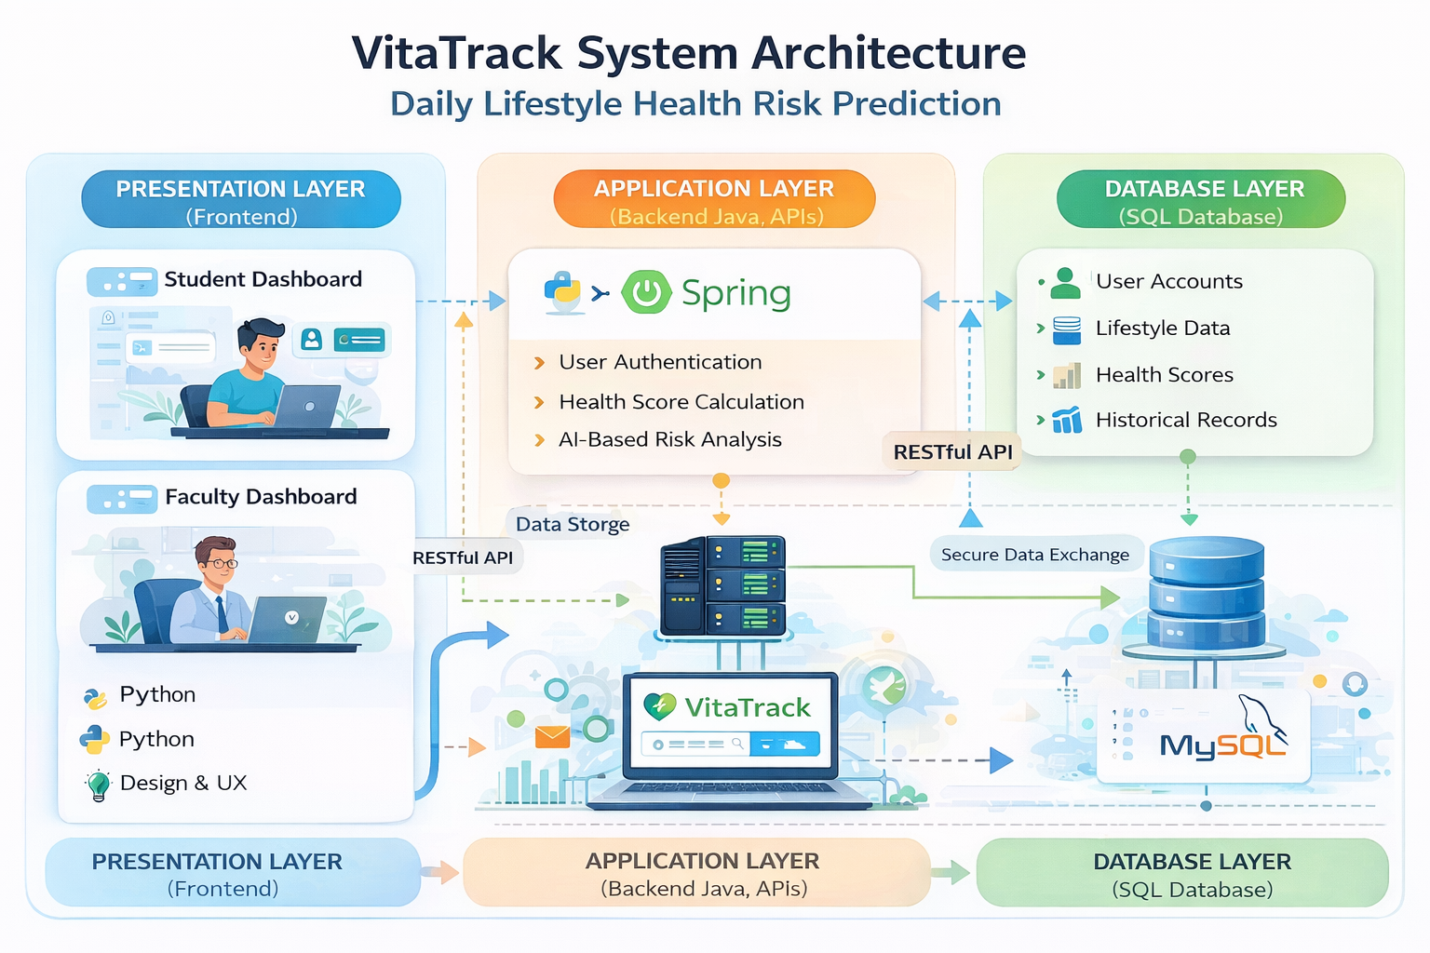

Once the user enters the data, the system sends this information to the backend processing module where health evaluation rules are applied. Each parameter contributes to the overall health score. For example, insufficient sleep, low exercise activity, high junk food consumption, and elevated stress levels reduce the health score, whereas healthy habits contribute positively to the score.
The system then calculates an AI-based health score which represents the user's lifestyle quality on a scale from 0 to 100. A higher score indicates a healthier lifestyle, while a lower score suggests potential health risks.
The next stage involves risk prediction analysis. Based on the calculated health score, the system categorizes the user's lifestyle risk into three levels: low risk, moderate risk, and high risk. This classification helps users understand their current health condition and motivates them to adopt healthier behaviors.
The system also provides visual representations of health metrics through graphs and charts. Radar charts and bar graphs are used to show how different lifestyle factors contribute to the user's health status. Visualization helps users easily understand which areas of their lifestyle need improvement.
Finally, the system generates health recommendations to guide users toward improving their lifestyle habits. Suggestions may include increasing daily exercise, maintaining regular sleep schedules, drinking sufficient water, reducing junk food consumption, and practicing stress management techniques.

- System Architecture
The proposed VitaTrack system follows a three-tier architecture consisting of the presentation layer, application layer, and database layer.
- Presentation Layer (Frontend)
The presentation layer represents the user interface of the application. It is responsible for interacting with users and displaying information in a clear and intuitive manner. The frontend of the VitaTrack system is developed using modern web technologies and the Streamlit framework.
The frontend provides multiple user interfaces including login pages, signup forms, health dashboards, BMI calculators, and lifestyle analysis panels. The design focuses on simplicity and responsiveness so that users can easily enter their lifestyle data and view their health reports.
Interactive elements such as sliders, input fields, buttons, and charts are used to collect and display information. Visual components such as gauge charts and radar charts enhance the user experience and make the health analysis easier to understand.

- Application Layer (Backend)
The application layer handles the core logic and processing of the system. This layer is responsible for managing user authentication, processing lifestyle data, calculating health scores, generating predictions, and providing recommendations.
The backend of the VitaTrack system processes the data entered by the user and applies predefined health evaluation rules. Each lifestyle parameter is evaluated individually and contributes to the final health score.
The application layer also manages session handling so that once users log in, they can access their personal dashboard securely. The backend ensures that data is processed accurately and efficiently before sending results to the frontend.
Additionally, the application layer supports the generation of charts and visual analytics which help users interpret their health metrics effectively.

- Database Layer
The database layer is responsible for storing all persistent data related to the system. This includes user account information, lifestyle data entries, health scores, and historical health records.
A relational database such as MySQL or SQLite can be used to store this information. Each user has a unique identifier that links their profile with their lifestyle data and health reports.
The database structure includes tables for users, lifestyle metrics, health predictions, and historical reports. Proper indexing and relational database design ensure efficient storage and retrieval of information.
The database layer allows the system to maintain user records over time so that users can track their lifestyle progress and observe improvements in their health scores.

- Implementation
The implementation of the VitaTrack system is divided into multiple functional modules that together provide the full functionality of the application.
- Authentication Module
The authentication module manages user registration and login functionality. New users create accounts using the signup page, and their credentials are stored securely in the database.
When users log in, the system verifies their credentials and creates a secure session that allows them to access their personal dashboard. This module ensures that only authorized users can access the system.

- Health Dashboard Module
The health dashboard is the central component of the application. It provides users with an overview of their current health status and lifestyle metrics.
The dashboard displays the user’s health score, risk level, and lifestyle analysis charts. It also shows important health indicators such as sleep hours, exercise duration, water intake, and stress levels.
Users can update their lifestyle data regularly and monitor changes in their health score over time.

- Health Metrics Input Module
This module collects lifestyle data from users through interactive input fields. Users enter information related to their daily activities such as sleep hours, exercise duration, water intake, junk food consumption, heart rate, and stress levels.
These inputs are then processed by the system to evaluate the user’s overall lifestyle condition.

- Risk Prediction Module
The risk prediction module analyzes the lifestyle data entered by the user and calculates the health score. Based on the score, the system categorizes the user's health risk into low, moderate, or high risk.
This module plays an important role in identifying potential health issues early and encouraging users to adopt healthier habits.

- BMI Calculation Module
The BMI (Body Mass Index) module allows users to calculate their BMI using their height and weight information. The system classifies the BMI value into categories such as underweight, normal weight, overweight, and obese.
This module helps users understand their physical health condition and encourages them to maintain a healthy body weight.

- Visualization Module
The visualization module provides graphical representations of health data using charts and graphs. Radar charts, bar charts, and gauge meters are used to display lifestyle metrics and risk levels.
These visualizations help users easily interpret their health data and understand which lifestyle factors require improvement.

- Technologies Used
- Frontend Technologies
The frontend of the VitaTrack system is developed using Streamlit and Python. Streamlit provides interactive components such as sliders, charts, and dashboards that allow users to interact with the application easily.
Additional visualization libraries such as Plotly are used to generate dynamic graphs and charts that display health metrics effectively.

- Backend Technologies
The backend logic of the system is implemented using Python. The backend processes user input data, calculates health scores, performs risk analysis, and generates recommendations.
Python libraries such as Pandas are used for data processing and analysis.

- Database Technologies
A relational database such as MySQL or SQLite is used to store user information, lifestyle data, and health records. The database ensures that user data is securely stored and can be retrieved efficiently when needed.

- Advantages of the Proposed System
The VitaTrack system offers several advantages compared to traditional health monitoring methods.
The system encourages preventive healthcare by helping users identify potential health risks before they develop into serious medical conditions.
Users gain awareness about how their lifestyle habits impact their health, which motivates them to adopt healthier routines.
The system provides real-time health analysis, allowing users to receive immediate feedback about their lifestyle choices.
Visual dashboards and charts make health data easier to understand and interpret.
The system is scalable and can be expanded to include additional health monitoring features such as wearable device integration, machine learning predictions, and personalized health recommendations.
By combining data analysis, visualization, and user-friendly design, the VitaTrack system provides a comprehensive platform for monitoring and improving lifestyle health.
